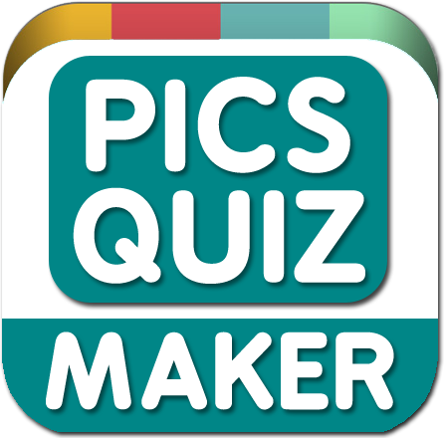



|  |  |
| --- | --- |
| Page | Title |
| 2 | How to start? |
| 3 | The Toolkit: CONFIGURATIONS (Coins options) |
| 4, 5 | The Toolkit: MANAGE THE WORDS/LEVELS AND IMAGES |
| 6 | The Toolkit: TRANSLATION OF WORDS |
| 7 | HOW TO CHANGE THE TRANSLATIONS OF THE UI? |
| 8 | How to change the sounds of the game? |
| 9 | Tools/Tools of my saved data |
| 10, 11, 12 | NORMAL ERRORS WHEN YOU ARE TESTING |
| 13 | EXPORTING THE GAME |

**How to start?**

1. *Set the resolution to the game.*

You will need create the Aspect Ratio: 9:16 and select it.

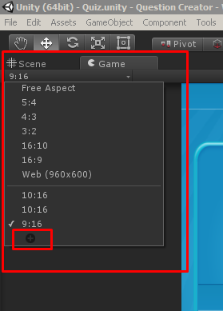 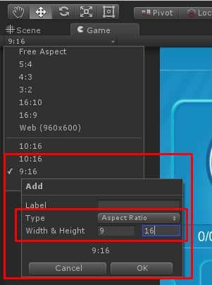

1. *Save the scene to the build settings.*

Open de Build Settings and later select the Scenes folder and drag and drop the “Quiz” scene to the Build Settings.

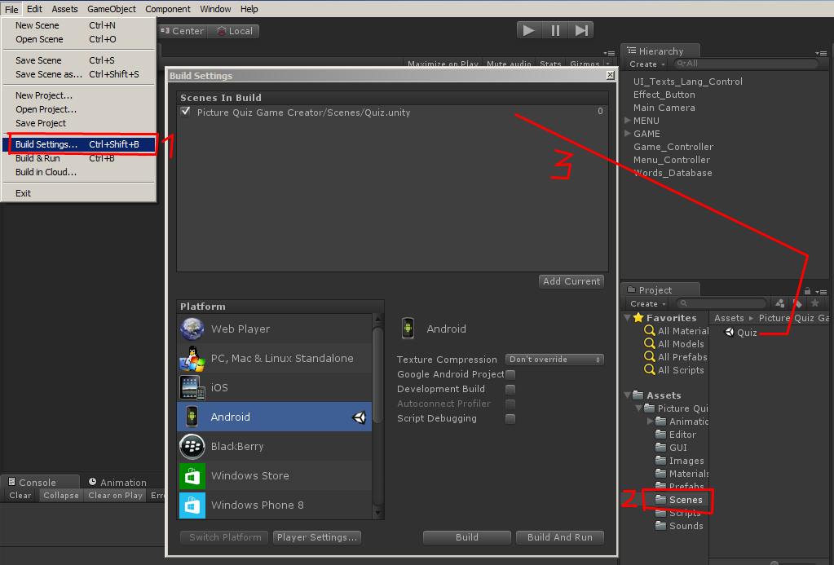

1. *Open the scene.*

If you don’t have the scene “Quiz” opened in Unity, double click on this to open.

**The Toolkit: CONFIGURATIONS (Coins options)**

**VERY IMPORTANT: Each important change, for example add new words, you will need save the scene pressing CTRL + S.**

These options is for the coins configurations

1. Click in the “Words_Database” game object.
2. 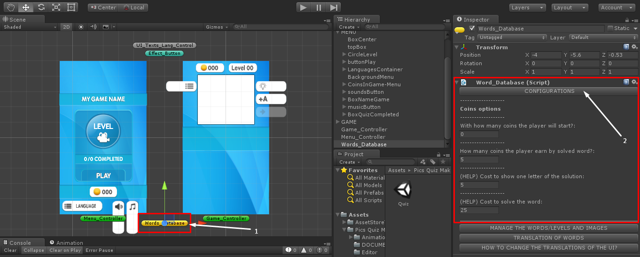Click in the button “CONFIGURATIONS” to open the options.

**The Toolkit: MANAGE THE WORDS/LEVELS AND IMAGES**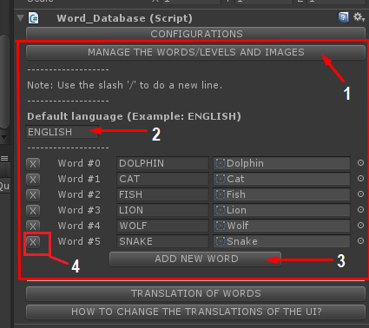

1. Click in the button.
2. Put the name of the language by default, for example: ENGLISH If the language by default will be English.
3. To add a new word you just need press the button ADD NEW WORD.
4. If you need delete some word, just press in the X button and the word will be deleted.

How to save set the image to the word?

1. Drag and drop the image into the “Images” folder.

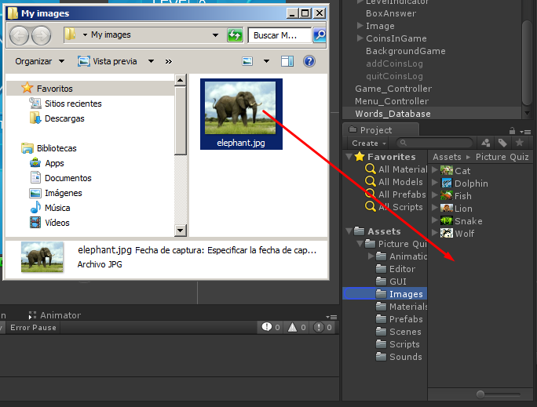

1. Add a new word and set the image to the word dragging and dropping an image of the folder.

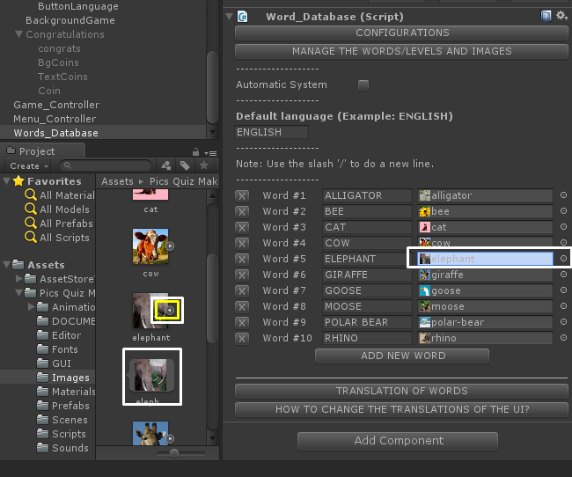

**Important:**

Select the images added and set these configurations:

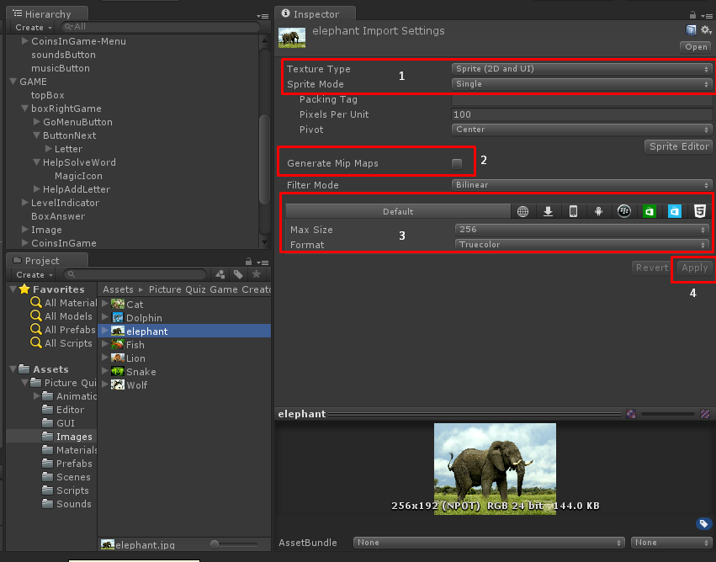

1. In the Texture Type set the option “Sprite (2D and UI)” and in the Sprite Mode set the option Single.
2. Set false (Unselected) the option Generate Mip Maps.
3. Set the Max Size in 256 (Recommended) or for best resolution set 512. In Format set: Compressed (Recommended) or True color if you preffer good quality.
4. Press the button Apply to save the changes.

**The Toolkit: TRANSLATION OF WORDS**

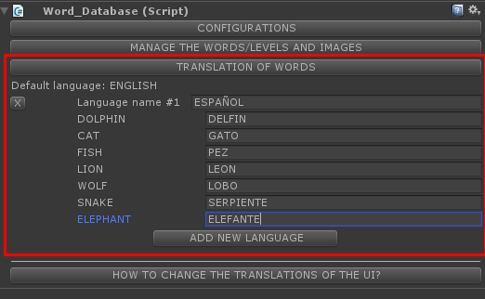

To add new translations just press the button “ADD NEW LANGUAGE”, or if you want deleted a language, press the button X.

In the "Language name" you will put the name of the language that you will use to translate the words.

These will be the languages that the player will select in the menu.

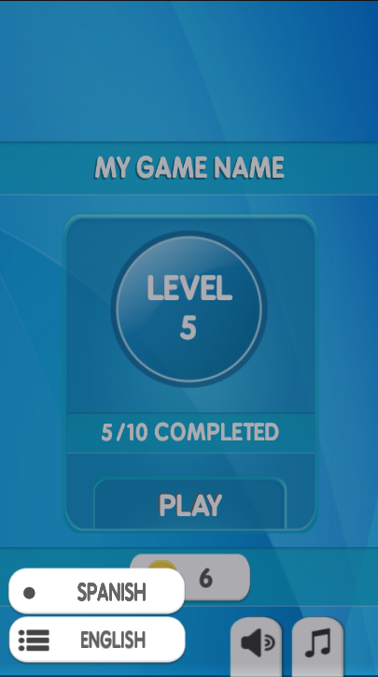

**HOW TO CHANGE THE TRANSLATIONS OF THE UI?**

Instructions:

1. Open the “Scripts” folder
2. Open Word_Database script.

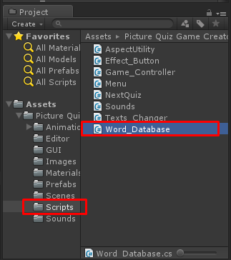

1. Read the instructions of the commented lines.

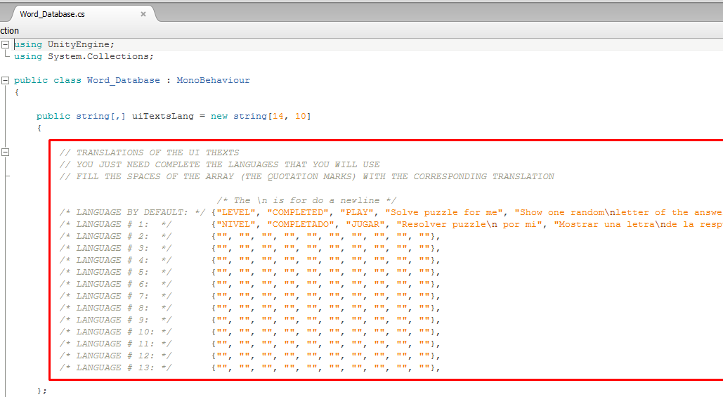

**How to change the sounds of the game?**

1. You will need have the sounds that you want in the game if you want to change the actual sounds.
2. Later that you have the sounds, drag and drop your sounds into the “Sounds” folder.

The supported formats of sounds:

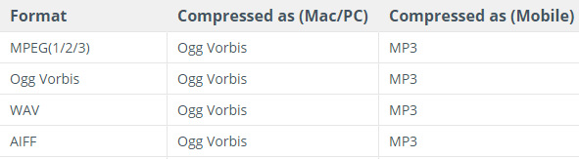

1. Select the camera
2. Drag and drop the sounds into the correspondent spaces.

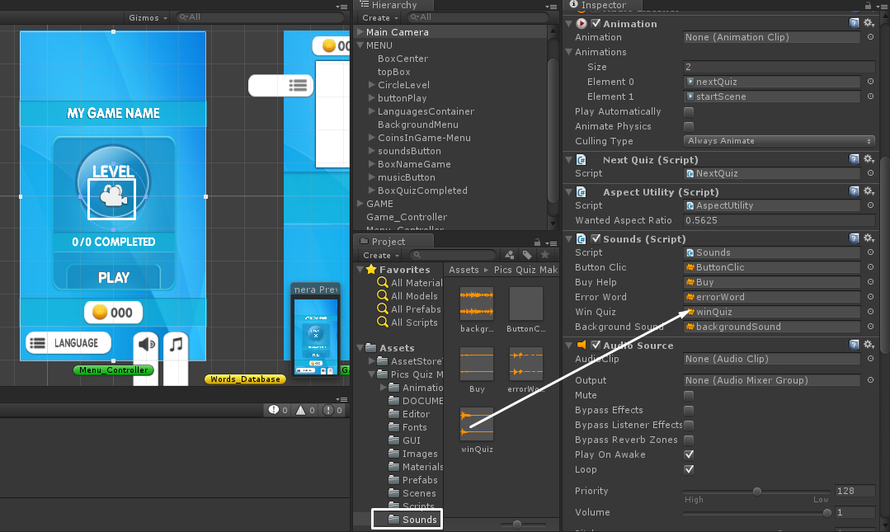

**Tools/Tools of my saved data**

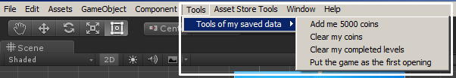

These tools will help you when you are testing the game.

**NORMAL ERRORS WHEN YOU ARE TESTING**

You can have 2 types of errors in console when you are testing the game:

The first error happens when you have for example X levels in the words_database and when you are testing the game, you are in the X level:

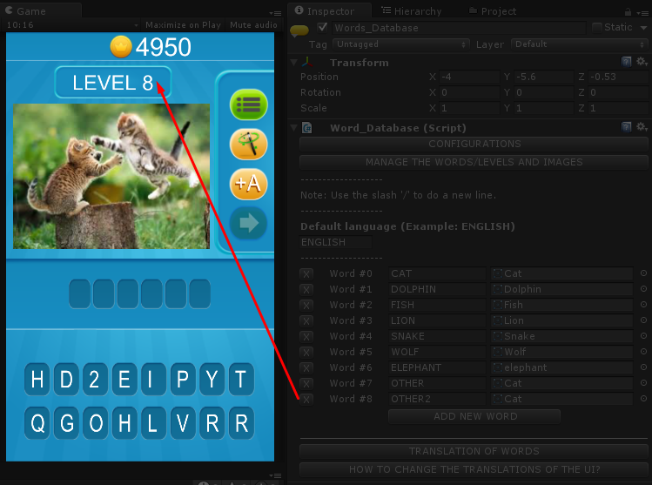

Later you quit the PLAY to the game and delete the word 8, later you put play and you will obtain this problem:

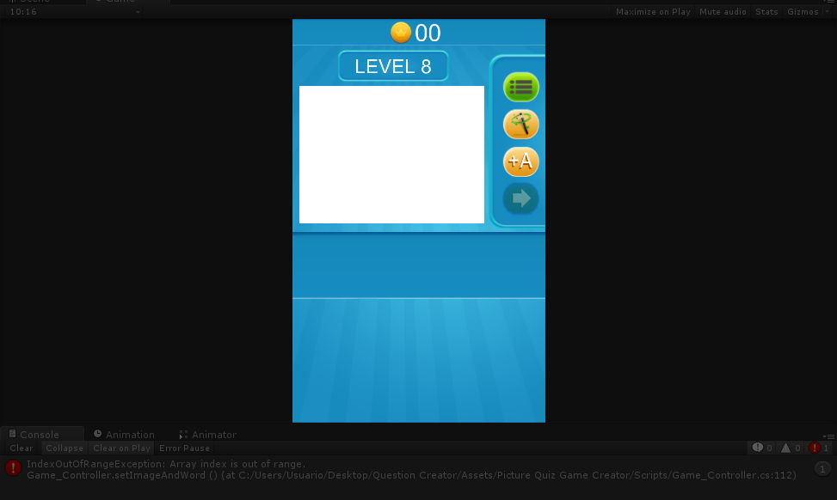

**How to solve this problem?**

You can do someone of these solutions:

1. Add the word 8

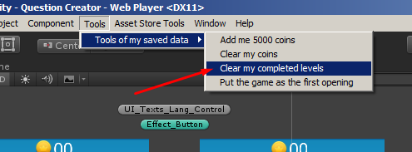

The second problem that you can have when you are testing the game is when you have for example 1 or more language translations and you select someone of the languages in the game:

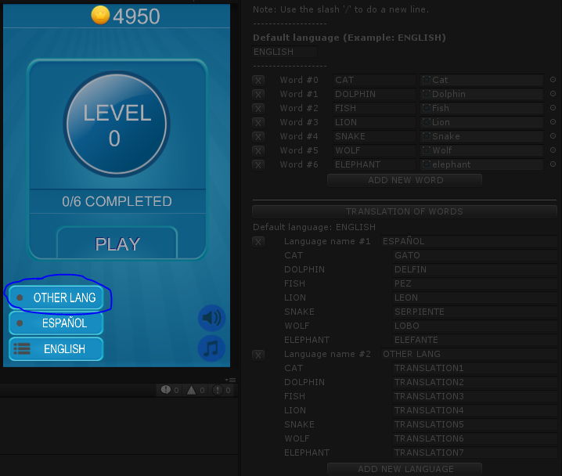

Later you quit the PLAY and you delete the language of the inspector and put PLAY, you will obtain this error in console:

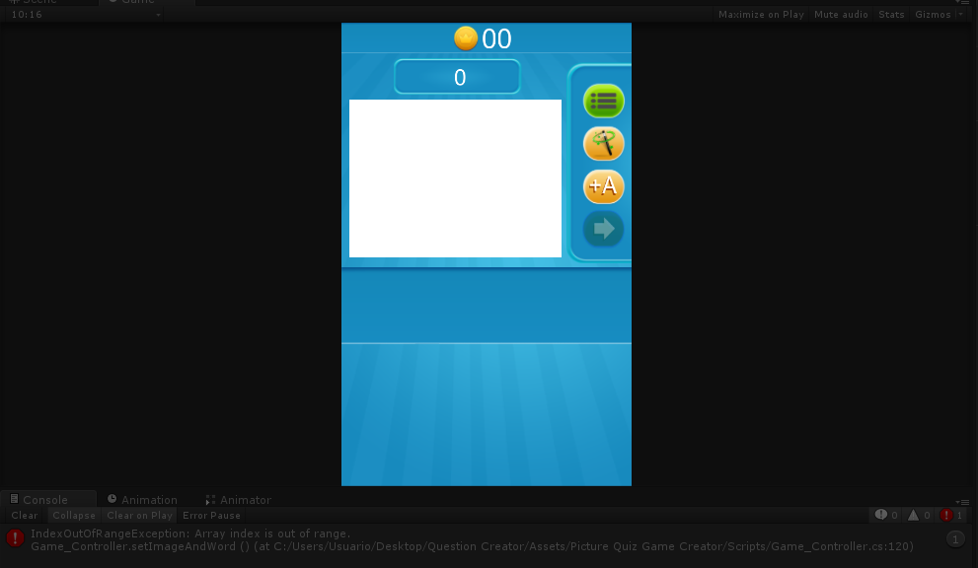

**How to solve this problem?**

You can do someone of these solutions:

1. Add the deleted language.

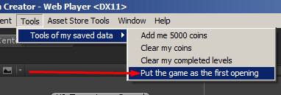

**EXPORTING THE GAME**

1. Select the platform to export and later click in the button Switch Platform.

You can export to some mobile platform, but you can export to PC if you want.

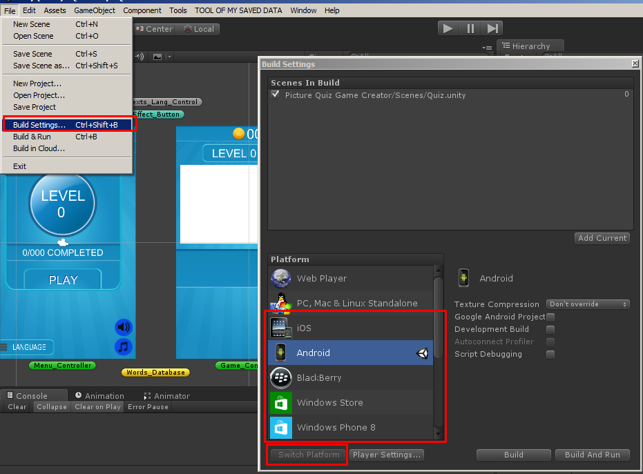

1. Open the Player Settings and later set the orientation in Auto Rotation and set Portrait.

